The Iceship And The NASA Space Meeting

A Zuppero, reformatted 2009.07.20 from presentation at 1998 meeting

Visionaries Meet
This was an Official, Invited Speakers Only, Highly Selected, Imaginative Ideas-Only, NASA meeting.

Workshop on
Using In Situ Resources for
Construction of Planetary Outposts

April 30–May 1, 1998
LPI Technical Report Number 98-01

It was Friday, 1 May 1998, 9:30 AM, Albuquerque, New Mexico, USA. Dr. Mike Duke of NASA had put together a collection of concepts that had stood the test of time. A Visionary for every idea that Mike Duke selected was still pushing their own concept. That was a good test. It was good because good managers and leaders know that the best measure of impending success of a concept is to see the Visionary still passionately dedicating their time to it, after a long time pushing. Mike collected the Visionaries. Mike personally invited me to tell of the IceShip.

A basement room big enough to seat 50 or 80 people. No windows. Good lights. Plenty of space in the back for free coffee. A big space for the speaker, with a table and a nice podium, very wide, along the length of the room, not the depth. A limited number of chairs. A select number of people. Everyone here was handpicked.

Plenty of room for visitors, but there weren’t many. Only serious visitors. Most of the space cadets had gone home already.

As we sat down and listened to the opening remarks, I looked around at who was there, who I might know. And then I scanned the agenda. I realized my presentation was nearly last and that most of what would be said here was recycled. It was chocked full of concept after concept of impractical things, useless things, untested things, old things, things we heard about many times before, and some things 3 decades old --- exactly what one would expect from those seriously planning to live on other planets.

My turn to speak was near the end of the list. I would have to wait and listen. I had no choice. I was also tracking this audience, my audience. I would have to just sit through this patiently. Something was bound to be interesting. Famous people were slated to speak.

Something nearly immediately caught my attention because it related directly to making a huge space ship cheaply.

A fellow named C.C. Allen described how to make strong bricks from moon dirt.

“Puzzle pieces. Snapped together by a machine,” I thought. The building-making-machine flashed into my head. A comic book during the 1950’s had a person driving a building construction machine with hydraulic arms throwing big brick puzzle pieces at a building, tossing the pieces high into the air, snapping them together on a growing building, creating big buildings super fast. C. C. Allen was feeding the memory of that thing I always wondered about.

Allen said all one had to do was heat the moon sand till it just melted, and the sand could cast into molds to make strong bricks. “Strong bricks, better than ice,” I thought, “sun heats ‘em. No electric required.” Those were feel-good thoughts. The "no electric" part was very good for space economics and engineering.

Four years earlier, Nancy Linarez and I wrote how we could use melted moon dirt to make a space ship. Now Allen was giving me details. I started to get excited. “How strong would it be?” I wondered.

He didn’t say how strong the brick would be if I tried to pull it apart. He only said how strong it would be if I piled them up. There is a big difference. I needed something that would hold a spinning space ship together, to keep if from flying apart. C. C. Allen left me without a key piece of information.

He also said the bricks would tend to crack if they cooled wrong. Bad. Not what I wanted to hear.

I kept sitting through the presentations, waiting for something new.

Many people told of how to use the dirt. A Visionary showed how to make solar power photovoltaic cells on the moon, from moon dirt. I was tempted to ask him if he could do this at a place just west of Albuquerque, about 30 miles from here, on the desert, from desert dirt. If not, how could he do that on the moon? If so, we ought to. That would be a mean question.

None of these things were new to me.

One Visionary showed how to suck oxygen out of rocks, moon dust. Since most of the rocks on the surface of the moon are oxides, there was plenty of oxygen to work with. The only known way to get the oxygen out was to use electrolysis. He would stick electrodes into molten moon dirt lava, connect the electrodes to electricity and electrocute the lava. Oxygen would bubble off.

So, that’s what the guy wanted to do? How original. I had heard about that one a decade earlier. It would be easy on paper. The concept had them electrocuting orange hot, liquid rock lava, making oxygen bubbles. I did not ask what happens when or if the container would cool. Would the result be an oxygen-maker completely clogged by solidified, rock-solid lava, and then we suffocate?

A Visionary named Jakes from the Czech Republic came to the rescue and showed a new way to get oxygen from moon dirt just using heat. That was new. He would just add a reducing medium such as coke, he said. I wonder where to get coke on the moon? The moon has no coke. The moon is carbon poor. That's why the iron specks making up 1% of moon dust are high quality stainless steel: they have no carbon. I kept listening.

At least several Visionaries talked about ways to use Mars dirt and Mars air. All the ways seemed a bit hard to do. Very hard to do. The Mars air is so thin an air pump would have almost nothing to suck.

Another Visionary fellow showed how to melt moon dirt and make igloos for shelters. They looked like blobs of melted glass doppled together, and then we were supposed to slither in there somehow, in our inflated space suits, without snagging them or cutting them on the edges of the melted glass corners, and call it home.

Should I speak up?

“Nothing in space would be better than the worst place on Earth. Even the coldest, bleakest tent in Antarctica during a horrible blizzard would be easier to live in and work in than anything on the Moon or Mars. So, why do you want us to pay for this?”

People asked us that "why ... us ... pay for this" question at the Department of Energy. Why can’t we ask these Visionaries the same question?

Worry started to come over me as I squirmed in my chair. Strategically seated in the last rows, so I could catch people of importance as they walked in or out, I got up and walked around the back of the room. Several people were standing, leaning against the wall, some drinking free coffee. Somebody was peeling open the little jelly containers and eating the jelly. The free jelly was put there for the free bagels and muffins that had long ago disappeared.

Worry started to overtake all my thoughts. Living in space would be horrible.

Perseverating, pacing back and forth, I thought:
“Where are the amber waves of grain?
Where is the trickling stream?
The oak and maple tree forests of Pennsylvania?
Where are the turkeys to shoot, the deer to eat, the fertile land to grow food?
Where are the corn stalks,
and the autumn pumpkin field?”

Space was awful, barren.

“Where is a stream of water?” I planned on asking the next speaker, whoever it was, no matter who.

“Where can I catch a rabbit on the moon?” I would ask. Perhaps the audience would laugh. I would not be laughing.

“Any fish on Mars?” I would ask the next Mars Nazi.

“Is the air on Mars still poison?” I would ask.

I would remind them “During that NASA space meeting in Tucson, January 1991, half the guys in the afternoon session were talking about how they would propose to avoid dying from the traces of carbon monoxide in the Mars atmosphere”.

I was there during January 1991. I heard them speak. That’s when I found out that the trace carbon monoxide in the Mars air would be fatal unless very carefully dealt with.

“How much would an acre of hothouse cost on Mars?” I would ask, and then quickly, before they could answer, ask “How about on the moon?”

No matter what they would say, I would then ask “You mean it would cost less per livable floor space than the cost of an airplane?”

An airplane is a mass produced space ship found and made nearly everywhere in the world. It’s cost is as low as they get. It’s a space ship that keeps people alive at 45,000 feet. At that altitude, the air is thin, 75% of it not there, and the airplane could as well be floating in the vacuum of space. My airplane example would be less expensive than anything and any rocket ship in space. Airplanes would be an extremely expensive hothouse.

I learned the hard way that outer space is too expensive.

No. There was no way living space on the moon or on Mars would cost less than the cost of mass produced airplanes. A nice, big airplane has a size that is smaller than the hothouse on my Uncle Gus's farm, and costs about $50 Million. That meant it would cost about $50 Million for a house, for only as much house as one could make out of a big, commercial airplane. What kind of civilization would that be? Expensive, and at taxpayer expense. That’s the kind of civilization it would be.

This was not going to work. Living on the moon would be way too expensive no matter which of the guys in this room had their way.

I kept listening, but my mood got worse.

A fellow named Ramohalli showed how to split the Martian air into fuel and oxidizer, and then use them. Unfortunately, it looked like he would take CO2, what I exhale, and split it into oxygen and carbon monoxide. The good part was that the Mars air is mostly CO2, so he could just suck in raw material. Great.

The bad part was that he would use electricity to split it. Once can only get a little trickle of electricity on Mars. A worse part was that he could not store very much. He was going to store both carbon monoxide and oxygen in what looked like some regular sized balloons. One can’t store a lot of gas energy in balloons.

The meeting was degenerating, according to me. The organizer, Mike Duke, seemed to be happy. The speakers seemed to be glad that someone let them speak at NASA’s special request.

Mike Houts from Los Alamos showed what seemed to be a rather exciting electric power supply. At first, it looked very good, 10 to 100 kilowatts, growing to 1000 kilowatts. 1000 kilowatts would power 100 homes where I lived, 1000 homes in Jakarta. Mike’s 1000 kilowatts of electricity in space would be a lot. But then I realized this was puny. On Earth, this is only about 1,333 brake horsepower. The same power as 2 or 3 eighteen wheeler trucks generate rolling down the highway.

The Human Occupation Of Space was thinking “amber waves of grain,” and “streams, fish, trees, a gentle breeze, sunshine, turkeys in the oak tree woods, long convoys of eighteen wheelers full of good stuff.”

But instead we were getting “a nuclear reactor, carbon monoxide, no water, sucking the oxygen out of rocks by electrocution, melting sand to make ceramic blob igloos.”

Anxiety, fantasy and reality were combining. Flashbacks to the first days of men-on-the-moon reminded me of how everyone during those days thought we were on the verge of becoming a space-faring Life Form. The first pictures that the NASA lander beamed back to Earth showed a Mars that looked just like some parts of the desert just west of Albuquerque.

“We found another Earth,” Dr. Bill Bishop had told me at supper, returning for a visit to Albuquerque from his new position at NASA. It was a fanciful, fantasy conversation, and we both thought it was completely real. But that was 20 years earlier.

Reality hit me. Our species was not ready to go to space. No Human Occupation of Space.

Steve Gillette and his colleagues were describing how to use lava tubes on the moon as habitats. That was a fresh thought. I had thought about this during the early 1970’s. Deep underground. Deep down in a labyrinth of caves, natural caves. Nicer caves that the ones drilled using Jim Blacic’s lava melter poker. Deep in lava tube caves near moon craters. Just like the Dick Tracy comic strip of the late 1960’s.

The Dick Tracy comic strip during the 1960’s had it all figured out already. Dick Tracy even had a wrist TV. In the comic strip, humans discovered a pretty moon girl with little horns who lived on the back side of the moon, where we never got a chance to see from Earth. On the back side, there was water deep in lava tubes or crater cracks. They lived somewhere deep in the moon where water was supposed to be. The Dick Tracy comic strip gave me the idea.

We would be going so deep down into Mars or the Moon that the air pressure deep in the cave, miles below the surface of Mars or the Moon, would be as thick as the air on a high mountain top. Almost normal.

But when I figured it this time, in my chair among 30 space Visionaries, I found out it would be dark. Absolutely dark. Always dark deep in a cave. Probably warm, too, because it would be deep into the planet and digging closer to its hot, molten lava, closer to the core of the moon. And if there were any water above, it would develop a crushing pressure after only a few hundred feet.

Steve Gillette was now bringing us the real story on moon lava tubes. Gillette and his friends were describing how air and ice would collect deep in the lava tubes. This would have been exciting. Except that now the Human Occupation of Space would be condemned to live forever underground, like ants or moles, but 1000 feet down, maybe 20,000 feet down.

Our skin would loose color. The only light we would see would be from our flashlights. Our skin would develop calluses, permanent calluses, scales, so we could be ok with scraping against the hard rough rocks. Our skin would develop temperature sensors, so we could better feel the heat of things, like a different way to see in the dark.

Awful.

I liked the lava tube idea. I bet we would actually find them on the moon. My mood got brighter. Gillette was a mineral person who worked in real mines and real mineral extraction for real companies on Earth.

Then his team made a special point that the sticky dust that is on the surface would not be there deep in the lava tubes.

Sticky dust?

I remembered that one. Bad. The dust on the moon sticks due to static. It sticks to everything. One can’t blow it off because there is no air to blow with. One can’t brush it off because it sticks to the brush. It is sharp and abrasive, so abrasive that a moon suit would wear out in a few weeks. Wheels and joints get the dust inside, and it grinds them, wears them smooth, and would ruin the all the machines on the moon.

I was pacing slowly back and forth along the back of the conference room.

At least the detail of what they were describing was really interesting.

My strategy to tell them a story seemed to be a good one. By the time it was my turn, they would all be pretty bored. They were all mostly Visionaries and had all mostly seen everything before.

But the bottom line reality became more and more clear. The reason the Congress is not funding anyone going to the moon or Mars is that
nobody in their right mind wants to live that way.
***

Submarines are Like Spaceships

It was my turn. My costume was carefully adjusted and checked for specks of dust. Suit and pants pockets were both emptied of everything, of anything that could bulge. Hair was perfectly combed. Beard had been trimmed. Face washed. Tie straight. Carrying only a handful of viewgraphs I confidently and purposefully walked up to the podium. General Dynamics trained me well.

I had been watching their every move, every response. I noted what they accepted and what they did not, what they laughed at and what questions they asked. In the hallways and during the breaks, I had made sure I was supportive of every concept, no matter how impractical or costly. I had refrained from asking embarrassing or combative questions. I saw they responded like any smart 4th grader, and that they understood what curiosity would uncover. These were the ultimate 4th Graders, the fully matured, intensely curious, proven smart Visionaries.

Placing the picture that said everything on the projector, I introduced myself and began:
“I’m going to tell you how to make a space ship out of ice.”

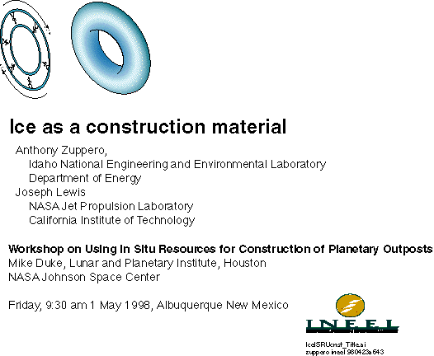

Pausing for a moment and looking at them, eye contact from one end of the audience to the other, like I had seen an aerospace company president, Norman Augstine from Martin Marietta did when he addressed private luncheon meeting, I continued with a story.

“Not that you should make one out of ice.
This is only a curious Coincidence of Nature.
It lets us inflate ourselves a monstrously big space ship.”

Then I acknowledged what several of the Visionaries in the audience had suggested.
“You probably wouldn’t do this,
use ice.

You would probably use melted regolith,
like some of you here told us.
You would melt moon dust
and make ceramic space ships.
Ceramic would definitely make a much stronger, sturdier, bigger space ship.

But this is interesting.”

I turned back towards the podium and the viewgraphs.

I knew exactly how to make this ice space ship. I was about to tell them exactly how to do it.

In sharp contrast, not a single one of them knew how to make a ceramic space ship, or anything else out of melted dirt. No one knew how to reliably spin strong, miles-long fibers from molten moon dust. The fibers would have made excellent space ships.

They did not even know how to make plates out of moon lava. Plates would really be neat. One could make plates that snapped together. None of them knew how to reliably and simply make strong, foot-wide ceramic tiles from just moon dust and focused sunlight. I was hoping they would. We were all hoping. They knew this.

If I would have heard anyone who could have been able to make fibers or tiles I would have changed my speech immediately, and made us all look like heroes.

They focused on me. I told them a short story of how I asked the key question. Visionaries always want to know how one gets to the key question. They all knew that the rest of any story after the key question would be easy.

“During 1990, Ted Fay assured me
“we will get you your water.”

I figured the ice part back during 1990 with some ice data I got at UCSD.

Gene Shoemaker called me one afternoon.
‘Told me about his finding water ice on a comet,
a comet whose orbit came tangent to Earth orbit once every 4.2 years

We published our result at Space 94. Nancy Linarez and I and Pat Whitman.

“Several years ago, the near earth asteroid and near earth comet people
told me there was water ice nearly everywhere in the solar system.

With water on the moon and water on the comets, I wondered:
how could we use the water ice to make a space ship?

Could we use it like cement?
Like steel?

Back in undergraduate school, during the early 1960’s
one of the metallurgists commented one day that
“if you freeze ice cold enough, it’s like steel.”

He lied or didn’t know what he was talking about,
‘cause it’s NOT as strong as steel.
Only as strong as a brick.
But I remembered his comment.”

I placed the viewgraph on the screen so they would see what I was thinking.

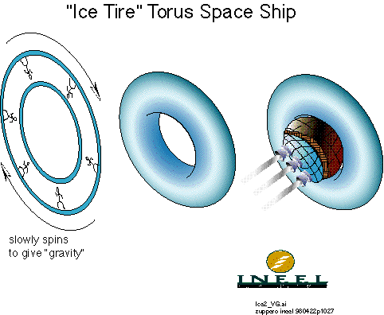

“We would be on the inside of a big rotating wheel.
A donut. A tube, an inner tube,
as big as a football field across.

We would spin it.
It would throw us against the walls.
Synthetic gravity.”

I pointed to the stick figures walking around the tube.

“See the picture?
There’s a guy walking on the walls.
The inside walls.”

It was obvious. I did not have to describe it in detail. They all knew that if we spun a cage, things would be thrown against the inside wall of the cage. If the cage were as big as a football field, a person thrown against the inside wall would not know the difference between that and gravity.

They only question you have is:
Will this ship rip apart when you spin it?

Would the ice hold up?
Is ice strong enough to hold together when we spin the ship?

That’s the key question.
Is ice strong enough so it won’t fly apart?”

That was the only question. From here on it was only a matter of figuring. Figuring the details. I went on with the story.

This was the same story I told 4th Graders, only this time I had every piece of the puzzle, and every number, and this made it real.

“All I had to do now was some simple figuring.
How strong is ice?
How strong do I need it?
How would I shape it?
How would I freeze it?

If everything went ok,
it would work.

‘It probably won’t work’
is what I thought when I started the figuring.

But I’m curious.”

Everybody in the audience was curious. They were all Visionaries and all space cadets. That kind of person is always curious.

This was straightforward to figure. Simplest thing in the world.

“So what’s the answer?” they all thought. I could see it in their faces. I scanned the audience again. They had that Smart 4th Grader look I had seen many a time.

“All I really need to know is
“will it fly apart?”

Well, before I figure that,
I need to know how big a ship to make
and how it is shaped.

Then I can just figure how strong ice has to be.
If ice is strong enough,
the ship is ok.

This was a trick. All they wanted to know was will the ship fly apart or not. I was tricking them into hearing every detail.

“I had make it hold enough people
or nobody would care.”

how many people to design for,
and how big the thing should be.”

I placed a viewgraph they could hardly see on the screen. All they could read were the 4, big print numbers.

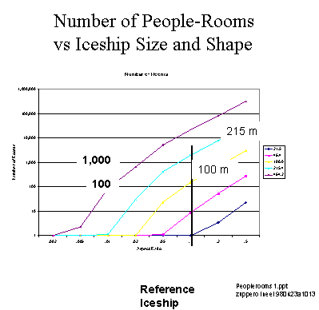

They could see “100 people” and “1000 people.” And they could see “100 m” and “215 m.”
I told them a micro-story about it.

“The United States Navy is an example.
A submarine has 150 people on a submarine.

They get that number based on skill sets.

An aircraft carrier can get away with 2000 people.

The figure shows my design could have 150 people in the 100 meter diameter space ship,
and 1900 people in the 215 meter ship.

Will the ice rip and break from the centrifugal force and fly apart?
Will people be dumped into space,
blood bursting from their eyes;
pain, torture, exploding eardrums;
trying to scream but can’t;
no air in their lungs?”

I watched to see if they got the joke part. The blood part. They did. They knew I was having fun figuring this. They sense I was figuring each detail in its turn.

I put the next illegible, incomprehensible viewgraph up.

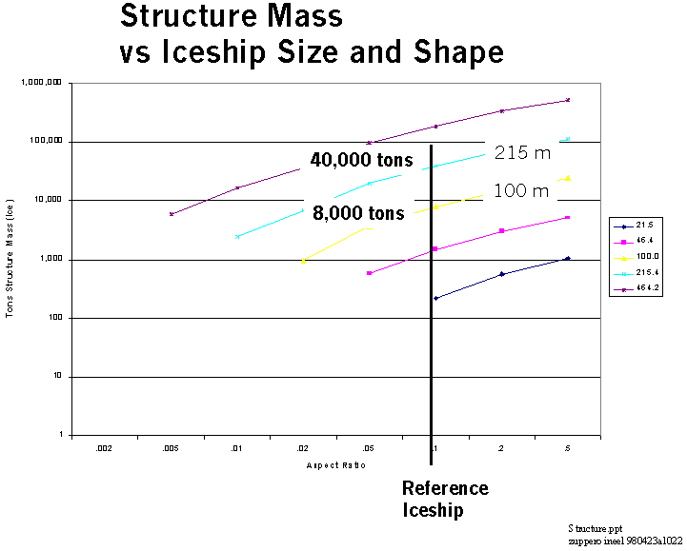

“Now we have to figure what shape to make it.

If we make the ship thin,
like a bicycle tire,
thin,
then it ends up with no room inside.
Too thin.

Astronauts.
Living cramped in a porta potty tube.
Bad.

Bicycle tire shape is the left part on this picture.
A big old doughnut or a bagel is the right hand side of the picture.”

They just wanted to know if the thing was going to fly apart.

I should have put little pictures in there. Bagels, doughnuts, bicycle tires.

“If we make it like a racing tire, like a really fat doughnut,
fat,
it is unstable and starts turning about the wrong axis,
like a coin flipping through the air,
like a tire flipping end over end instead of rolling.
Bad.

I picked a shape that was something in between.

This viewgraph shows how much it weighs.
You pick what it looks like
and how big across it would be.
The spreadsheet tells you how much it weighs.

If we make it too big across, it weighs too much.
If we make it too small, like a merry-go-round,
it’s so small that
everyone gets sick spinning so close to the axel.

So, I have decided:
Each person gets 100 cubic meters of space.
that is the volume of the biggest motel room in Idaho Falls,
the one for Moose hunters.

I decided to make it somewhere between
one football field and two football fields
across,
It will hold between 100 and a couple thousand people.”

“Then I calculated how heavy,
how much mass
how much ice the ship would be.

The mass came out between 8,000 and 40,000 tons

Anything under 50,000 tons
is ok.
We can get 20,000 tons of water,
from the moon.
Maybe 50,000 tons.”

I put the next viewgraph, still not telling them if it was going to fly apart or not.

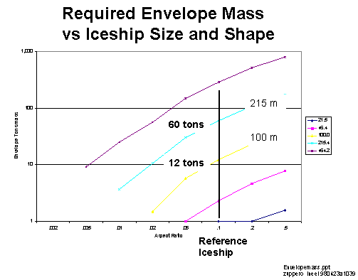

“How would we actually make this ship?” I asked the audience?

“How in the world would you make a torus,
the inner tube of an automobile tire,
100 meters across, and with 1 meter thick walls,
walls of ice?”

Waiting deliberately for their response and judging from the look on their faces I could see it wasn’t obvious.

“You put a plastic bag around the outside of the tube to keep the water in,
you put a plastic bag up against the inside of the tube, to keep the water out of the tube,
and you freeze the water between the two bag.”

I knew this was so unclear that it needed to be repeated.

We would launch a bladder,
some plastic bags,
and inflate the space between the bags with water.
The walls become the walls of the space ship.”

It wasn’t clear to me that they got the picture. By now, having told this story so many times to 4th graders and rocket scientists alike, I realized it didn’t matter. They just wanted to hear the story. So I asked them the key question about the plastic bags.

“What really matters is what we launch,
the weight of the plastic bags,
the mold,
the thing we inflate with water.”

I wanted them to understand that
it’s dollars that count,
not so much how much the ship weighs.

“How much would the plastic bag weigh?

That’s the only thing that counts,
‘cause we have to pay for launching it.

If the water’s out there,
we have to launch the bucket
to carry it.

How heavy is the water bucket?
How heavy are the plastic bags?

Maybe we launch them on the Space Shuttle.
25 tons is the Shuttle payload.
Anything under 25 tons would be ok.

120 tons is the Shuttle itself.
Maybe launch the plastic bags instead of the Shuttle.
Anything under 120 tons would be ok.

What you see on the chart is what we launch.
That’s what’s important.
How much we have to launch.

The plastic water bags would weigh
between 12 tons and 60 tons.
Not so bad.”

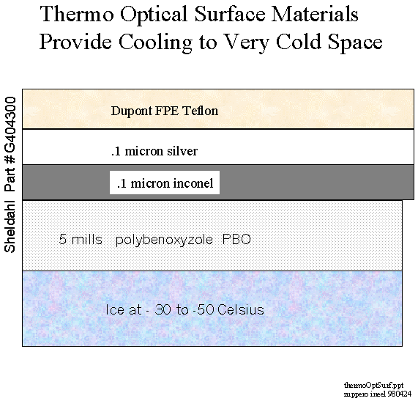

I still wasn’t done. If we would have to take a refrigerator along to freeze the water, this idea would not work.

Joe Lewis at TRW saved the day. He knew exactly what to do and how to do it. A decade earlier, I had learned how to calculate how to paint a space ships to make it either freeze or heat up. Space is cold, minus 450 Fahrenheit. We want our space ships to stay warm, not freeze up. So we usually go the other way. But Joe Lewis knew in detail how to freeze the ship.

Joe Lewis at TRW would coat the plastic water bag with a commercial coating that would make bag radiate heat away. He identified it.
“Sheldahl Part Number #G404300,” he bragged.

It would be like an anti-blanket.
Anti-thermal underwear.

They now had all the pieces.

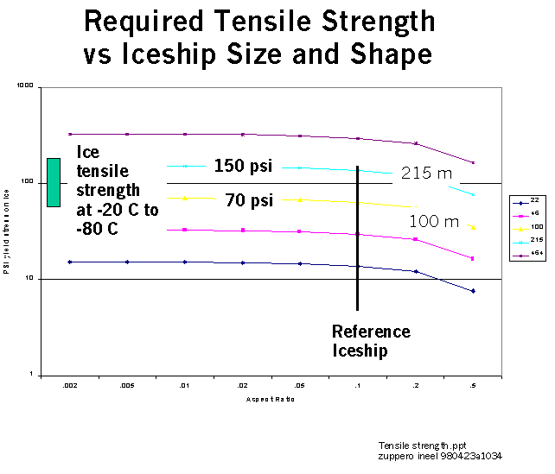

“Well, this says the ship won’t fly apart.” I said, as I put the last viewgraph up.

“The only data I could find was about river ice. Dirty water ice,” I declared, with a bit of exasperation.

“River ice with no bubbles and low salt has a strength of between 70 and 150 pounds per square inch,” I stated, dryly.

“That’s about half or a fourth as strong as a red brick.
Not very strong,
But plenty strong enough.”

“The big ship needs the stronger ice, 150 psi.”

I was done. So I summarized it:
“So, it won’t fly apart.
Seemed interesting to know.”

Now I waited for questions, killer questions.

If they would kill my concept, I would give up and use space bricks.

Or, I would give up and use a cage held together by steel cables.
I had figured that one out, and it worked perfectly ok.
A little heavy, but ok.

The ship would be made of whatever they wanted,
and would be held together by steel cables.

They could not ask me anything I wasn’t ready to answer. I was prepared.

It was just like Mike Griffin told me 5 years earlier,
“they can’t ask me a question I can’t answer.”

“All water has bubbles,” somebody volunteered.

“Of what?” I asked,
“Carbon dioxide? Air? Nitrogen? Oxygen?”

“This is space water.
There ain’t no gasses in that water.
But if there are,
great,
I’ll use them,”
I declared.

Then I decided to toy with them.

“You know, ice is plastic if it’s a little warm,” I volunteered.

“It creeps,” I said, as I looked around the room, with a bit of a smirk on my face.

They all knew what that meant. I saw several of them start to chuckle. It meant it would slowly flow, a bit like silly putty. It would just slowly stretch and then snap.

People would be dumped into space. Gasping for air. Eyeball blood vessels bursting. Choking but nothing to choke. Ear drums bursting. Blackout. Arms and legs stretched out, slowly rotating, moving away from the space ship, floating forever in the black of space.

A shower of little chunks of ice slowly spinning and reflecting sunlight where a space ship used to be.

“Does that kill it?” somebody asked.

“We wondered how to keep it from creeping. Actually, you could use duct tape. You could make duct tape strong enough to keep it from creeping.”

Even Mike Duke, the conference leader and funder chuckled when I said “duct tape.”

“You would probably use a role of steel cable,” I declared, sending the message that this whole scheme would work.

“Are the astronauts going to freeze to death?” somebody asked, laughing, waiting for me to answer the obvious question. He acted like he knew I was ready for the question and that he was my plant in the audience. He was smirking.

“Awh, heck no.
They don’t freeze.
They just put on their igloo suit instead of a space suit,” I retorted, taking my cue.

“These guys are Ice-tro-nauts.”

After the chuckles quieted down, I added
“It would be a bit like sitting against your refrigerator, the ice cube part.
A little bit of insulation and
just like Eskimos,
ice on one side,
and you, comfortable, on the other.”

