ppt 025 ice ship
4966 words 12/30/2007 10:49:28 PM
A. Zuppero

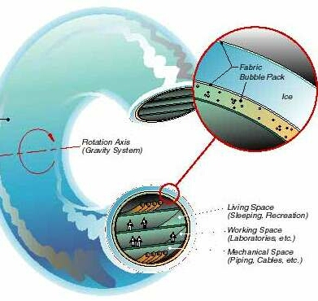

Ice Tire Space Ship, version by illustrator David Combs, Department of Energy, Idaho National Laboratory, A Zuppero inventor.

------
A spaceship made of ice

On a black, star-speckled day
of the extreme cold vaccuum of space,
a deflated plastic bag.

Its walls inflate with water.

It's a
big wheel,
like a tire
but as big as a football field,
or as big as the stadium itself,
in space,
weightless.

And it slowly freezes into
ice.

Spinning slowly
the wheel became a spaceship,
made of ice.

A coincidence of Nature
that it would work.

Suspense at the UCSD Library.

During the autumn of 1990, sitting in a "Village of the Dammed" for Program Managers in San Diego who were displaced and out of a job because the Cold War ended, I had time to think. My last job was to make space ships that shined a bright, blue laser down from space and into the ocean, to communicate to, but not from, submarines that were moving silently, very deep, somewhere, anywhere, only they knew where.

My first choice for my next job was to make space ships, space ships powered by steam rockets. My near-earth-Object astronomer friends had found ice in space for me. They found a whole formation of comets between here and Jupiter. I had calculated that at least one of those icy comets ought to be accessible. If there were any accessible ice out there at all, everything would work.

Ice? A metalurgist named Tom Krotine made a remark to me one time, back about 1964, that ice was almost as hard as steel when you got it cold enough. Krotine was an upperclassman back at Case Institutue of Technology when I was an undergraduate. You believe the upperclassmen as if the were God. So, if there were ice out there in space somewhere, for example, on those comets, could I use it? To make a space ship?

Could I make struts and beams and space ships using ice? Space is sure cold enough. The ice should become strong like steel, just like Krotine said.

I wondered: How can I use ice as beams, struts, or like a cement, in space, for making space ships?

Could I make a huge Gyrotron?
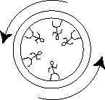

We rode the Gyroton once, long ago. A Gyrotron ride was like a big squirrel cage. When they spun it fast enough, with everybody lined up against the inside wall, it threw us against the wall and kept us there. It was like gravity.

There was nothing magic about this. All we had to have was a strong enough cage. Would ice be strong enough?

When the diameter of the big squirel cage is big enough, you can not tell the difference between gravity and being thrown against the wall. So, I would spin the space ship to throw the guys against the wall. That would create an artificial gravity.

It would look "kinda wierd." If the room you are in had round instead of flat walls, you would be walking around the walls, your feet on the wall, your head sticking horizontally inward, and you walking around the room on the walls.

I would show many a 4th grader this.

It was so marvelously graphic. I would tell this to every group I ever told this story. In every auditorium, I would point to the wall and show with my fingers-doing-the-walking how it would be. It always looked wierd. Everyone got it when I pointed to the walls of the room we were in.

It had to be at least as bigger across than a Merry-Go-Round. Otherwise, if I made the space ship tire much smaller than a football field, then their heads would spin a different speed than their feet, and they would just get very dizzy. Everyone would get dizzy, permanently. They would be seasick in space and have nowhere to throw up.

I had to spin my space ship fast enough or there would not be enough artificial gravity. The space ship has to spin at least enough to make us not weightless.

The Russian Cosmonaut Georgi Grechko told a group of us all about the sick and dizzy of weightlessness. He told us how he would hold on as tight as he could and pull himself into to his Cosmonaut chair for 10 minutes, as soon as they got weightless.

The young astronauts floating in the space ship thought Grechko was nuts and just a strange old grampa. He laughed, in Russian. And he didn't throw up. They did. The throw up was weightless and it floated everhwhere. It smelled very bad. And they all had to breath it.

In low gravity, our immune system would also stop working, and we would get sick all the time from everything. And, our bones would become brittle like chalk. And then we would die in pain.

If I made the inside of the tire too small, the Icetire Space Ship would look like a long, narrow tube, like a never ending sewer pipe. The place would be cramped, and people would get claustrophobic. It would be too small and they would all go crazy. It would be just like being in jail. It would be worse. It would be cruel and unusual punishment.

Any 4th grader could think up this kind of space ship. And, the idea could be a total hallucination if the ice is not strong enough. In that case, the ship would fly apart.

To figure out whether or not the ship would fly apart you needed to know how strong ice was and how cold you had to keep the ice to keep it strong enough.

If your ship ever melted, you would be in trouble. Since you are hot enough to melt ice, you better find a way to keep you from melting your space ship. I wasn't too worried about that part because we have a refrigerator in our house. The ice in the refrigerator seems to be ok.

And even if you did find out somewhere how strong ice was, you still had to know what to do with the number you found.

What would you do if I told you
"the tensile strength of ice is 600 kPa"?

I didn't know either. I had not done this kind of problem in 20 years.

You alo needed to know how to figure the amount of tension the ice experiences when the ice is trying to hold a spinning space ship together.

Did the size of the ship matter? Could you make a ship as big across as a city?

A smart high school senior could figure all this, nowadays. Back in the old days, when I was in college studying Physics, I would not learn how to do this until I was a sophomore.

This was a standard kind of "vector statics" problem.
On a homework problem you would see something like:
"Derive the equation relating the strength of a material to the tension in the strands holding a spinning wheel together and keeping it from flying apart"

I had to derive it from vector statics. Fortunately, the equations were not that hard. It was only rocket science.

I could figure everything except one thing: how strong is ice?

After only a couple of hours I was on my way to the engineering library of the University of California at San Diego (UCSD).
I just had to find out.

Would an ice space ship the size of the UCSD technical library building fly apart?

As expected, the technical library had almost nothing about ice. To figure this one out I needed to find someone who measured just how much weight an icicle would hold before it broke.

Imagine hanging on to an icicle, with gloves on, with steel studded gloves to get a good grip. Now try to figure out how thick an icicle it would take to hold you up.

Krotine said the ice would need to be very cold. So, imagine you are in Antarctica, hanging on to a big icecicle, with very highly insulated gloves, with steel studds on the fingers, at 60 degrees below zero in a 90 mile an hour blizzard wind.

Looking this up could be a real problem. What would the technical articles have for titles? What would the subject be to look them up? I had no idea and could only guess.

Who in the world would care?

And, there was no Google and no Wikepedia to help you. Today, just type in "tensile strength of ice" and you get pages of data.

If you asked for help, then or today, like asking a Professor in Mechanical engineering to help you, he would yell at you and tell you to do your homework.

I found only one book. The book was an old and clearly unused old book that had grainy black and white pictures and some measurements in it. Apparently almost no one cared about ice. Someone had cut nice little beams from three kinds of ice: river ice, stream ice and lake ice. They were careful enough to measure how much air bubbles, dirt and minerals each piece of ice had. Then they measured how much pull it took to break them. They were going into streams and rivers to get the ice. I don't know why they took these measurements. But, they had real data.

I also found a few technical papers on microfilm. There was just so little data it was almost not worth the nickels it took to copy them. At least I found out how strong the ice would be.

All this had absolutely nothing to do with space.

I had the data. And it was late and I had to go back to the Village of The Damned. It was more important to get a job than to figure if I could make a space ship out of ice.

Making space ships out of ice is not part of looking for a job.

As I was driving the 15 minute commute back to may office I kept thinking about it. The ice was pretty weak. The "strength" numbers were too small, hundreds of times smaller than the strength of a piano string or a coat hanger wire.

I was betting, in my mind, that the ice would break and there would not be no such thing as an ice gyrotron space ship.

I thought that guy from the Metaulurgy department, Tom Krotine, didn't know what he was talking about. Ice is weaker than a brick. He said it was as strong as steel. Maybe river ice was not cold enough.

I still did not know the answer.

There could still some ways out, in case the ice was just too weak. Maybe Astronaut Buzz Aldrin had figured it. Maybe that was why Aldrin put an astronaut house at each end of a long steel cable. The first time I met Buzz he explained to me his spinning, "two space cabins on long cable" concept. He knew we had to have gravity or we get sick.

Or, maybe Aldrin didn't have enough building material to make a big cage, so maybe he was forced to put the cages at each end of a long cable.
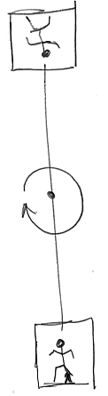
Buzz Aldrin's artificial gravity scheme.

Do I make something that looks like a giant inner tube, a giant car tire, and make the walls out of ice? Do I make a tire with spokes, using long, ice pillars as cables?

The whole thing could be absurd. I could not know until I got back to my desk.

Will I need to make the walls be 50 feet thick just make it strong enough to hold 3 or 4 astronauts?

I was driving. I could not do it while driving. I had not calculated things like that in so long that I could no longer do them in my head

What a pain.

If I didn't figure this out, I would not know the answer.

Slow Motion Calculating
Back in my office and with a piece of paper in front of me, it was easy. I analyzed it all in a few minutes, the rotating cage compared to Aldrin's two houses at each end of a long cable, both spinning in space. If a long cable would be better, I could use a strong, long icecicle.

The vector stress and strain equations showed that it didn't matter if I made it like Buzz Aldrin did, two cages, one at each end of a long cable, or if I made it like a giant tire.

I liked the tire because I could run around the inside for exercise during those long trips to Saturn. The tire would be as big across as a football field, or the entire football stadium.

Imagine yourself in the stadium. The space ship would be as big as the entire stadium.

I would make it as big across as a "boomer" nuclear submarine.

As an executive of General Dynamics, the Satellite to Submarine Communication Program Manager, I was escorted on a special tour at the nuclear submarine factory. It was a special tour inside a monster submarine that carried nuclear tipped missiles, Capitalist Holy Saviour Intercontinental Ballistic Missiles, to retaliate and hit back at the Commie Pinko Rapist missiles, if the commie bastards ever shot theirs at us. It was the tail end of the Cold War. We were fighting the commie pinko rapist atheists. They called that kind of submarine a "boomer" because it carried the big boomer atomic bombs.

Officers in the monster boomer submarine would be under the deep dark ocean for months at a time, with no windows. They needed exercise to keep from becoming flabby and going crazy. They told me a key fact: jogging seventeen laps around the nuclear tipped missile tubes hallway to go one mile.

My Iceship Starship would be like a big tire, as big as a boomer, so Astronauts could jog around it.

The tire would be more like an Icetire Starship Submarine.

I used the numbers for the strength of ice I had just found.

I wondered what the answer would be.

I could not go home now. I was too close to finding out the answer, the final score of the game.

If I went home instead, I would probably try to push the calculator buttons while I was driving and crash into somebody.

I was so close to finding out the answer that seconds seemed like minutes.

Suspense was happening, because I knew that if it worked out, we could make huge space ships easy.

If not, oh well, I'd be home a little late.

Would the ice be so weak that the thing tore apart,
like a tire made of wet clay or silly putty?

Would it hold together?

Suspense.

Pushing the calculator buttons was like slow motion.
Be sure to put in the right value for G, gravity.

Do all the numbers in metric, meters.

No mistakes. I make mistakes often.

I want to know the answer right away.

No Mistakes.

Make it one football field across.
As big across as 1 football field,
100 meters.

Put in the number for the strength of ice,
the best one,
What was that best one?
the one with the strongest ice?
Where was that "best one" number?

Now press the "equals" = key.

Suspense, in slow motion.

"Hey."
" ! "

It worked, almost, close enough to fix.
Just barely didn't work.
Just barely flew apart.

Slow it.
Don't spin it so fast.

Put in Moon gravity instead of Earth gravity.

Press Equals.

The answer was good. The stress on the ice was less than the yield stress.

Wow.
This could work.

Just to see how bad it might be, I used the worst value in the technical paper they found for the strength of ice.

Sure enough, use bad ice and the ship flies apart.

Bad ice would not be strong enough to make an ice tire space ship. I could make the ship out of bad ice, but if I try to spin it, the ice would break and the ship would fly apart. I could use good ice and spin it, but I would only get as much gravity as I would get on the moon.

Moon gravity was not so bad. Probably enough to keep us healthy.

It would work.
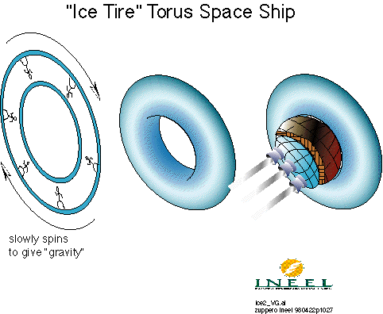

As a reward for finding something startling, I daydreamed a bit about what it would look like if the ship might break.

Maybe some meteor hit the ship and broke it. The mind picture was fun. Sparkling pieces of ice tumbling in space, chunks of space ship slowly separating, slowly rotating and discombobulating against the dark vacuum, with stars in the background, astronauts floating with their mouths open and their eyes bloody as all the air rushes out of their lungs, the blood vessels in their eyes popping, the blood doing that cold boiling of a vacuum, leaving a frozen frosty bloody color bubble foam on their faces.

Ice vapor turning into fog and looking just like a comet tail.

Dead people slowy tumbling in the hyper cold, vaccum of deep space.

People on earth looking up and seeing the comet tail,
and hearing on the radio that the iceship blew up.

But if I used good ice and a safety cable, we ought to be able to fix that.
A steel strap around the outside of the ice space ship would stop bad things from happening.

I heard multiple times that humans needed at least half the gravity they get on Earth, or their bodies don't work correctly.

This triggered a flashback memory, to the first time that I heard that our bones can't take the zero gravity. I knew we would have to fix that if we would ever go to space. I had just fixed that, with the ice tire space ship. But the flashback took over.

Flashback:
Dr. Bill Bishop had told me how our immune system fails. During the mid 1970's he came back from Washington DC to Sandia in Albuquerque. He visited after he left Sandia and went to work for NASA. We were sitting at an expensive restaurant near the airport. He was visiting and he asked me to supper. We were talking about those fantastic pictures the space probe sent back from Mars.

The pictures were simply stunning. I got all excited and told him that we could live there. I told him how I saw pictures of dried up river beds on Mars, just like we see from an airplane looking down at New Mexico when we are flying back to Sandia from Las Vegas and the Nevada Test Site. The space probe showed ice at the poles of Mars, and clouds.

"We could live there. It's another Earth." I blurted to him, completely excited, trying to convince him that NASA should try to go there.

Then I saw a tear starting to come out of his eye that he was trying to hold back. he was all emotional and choked up.

"You see." was all he could say. He was choked up that I could see that humans had found another Earth, and that we could go there.

Then he became technical again and he told me Bad Things happen if I don't live in a strong enough gravity. The astronauts learned that bones loose calcium.

"With no gravity your immune system quits,
and you get sick easily and
you die."

The Flashback was over. I was happy because I had solved the space immune system problem with my ice tire space ship.

I really felt great.
Dirty ice from a regular frozen river won't work.
Pure ice with no dirt and no bubbles will work ok.

Fantastic! With that pure ice, I could make a ship as big across as one or 3 football fields.

I can make a Starship Submarine like a giant stadium, out of ice.

ice would work.
-------

Asteroid Brick Space Ship

Inflate the Ship

Occupy the Solar System.
That was the objective.
But it would cost too much.

Maybe we could make a brick space ship,
or a locking-ceramic-tiles space ship,

or maybe we could inflate the space ship with
liquids, and let them cool down
and solidify.

Then we would have a low cost space ship.

There had to be some way to do this
that did not cost so much.

It was 1993, at the Idaho National laboratory, Idaho Falls, Idaho. Frigid Idaho. Nancy Linarez-Royce wanted to help us with making an ice space ship. It could be useful for her getting a Ph.D.

Nobody had yet found any water in space that was close enough to use.

And the biggest reason we were not
going to Mars
or occuying the solar system
was that it cost too much.
way too much.

Need a Thick Space Ship
Space was so dangerous.
Galactic Cosmic Radiation was everywhere.
The radiation would penetrate
right through any Space Shuttle wall.
Teeny tiny cosmic rays would then
punch through your body
like atom-sized bullets.

They would
leave a tiny meteor trail inside you,
flashing a faint flash,
poking a
super thin line of extremely hot fire,
so thin you won't feel it.
Like a white hot
spider web.

And bright enough
that you actually could see the flash in your eye
if it would happen to go through your eye.

Every astronaut I ever had supper with,
or lunch with,
saw this "eye flash" in their eye.

It is their badge of courage.
It happens in their eye on the average
about once every 3 minutes.
That is a lot.

This was no joke.
The white hot streak would go
through your legs, or
through you heart,
or your stomach,
your brain,
go in one armpit and come out the other.

A few would even go in your head and
come out your foot.

This was really no joke.
You would need at least 3 feet, a meter,
of ice or dirt
between you and space,
just to shield the particles
a little.
3 feet of ice was
only somewhat good.

You would get "50 Rads" per year
if you only had a NASA space ship
headed for Mars
like the plans they showed us.

I get about 0.060 here in myhome.
Denver gets about 0.3 per year.

That "50 rads" would give you 1% chance of
deadly cancer
every year in space.

You would be completely and totally poked full of
microscopic bullet holes
from the space radiation.

Ah, but I could fix that.

If I put 1 meter of ice between
space and me
I would only get 5 Rads per year.

Dr. Bruce Schnitzler calculated that one.
He showed me the data. Real Data.
He worked at the Idaho National Lab,
of the Department of Energy.
He did those calculations for the
NASA Lewis Research Center
when he spent a year there in Cleveland, for them.

Except that 5 Rads per year
of space radiation would still be
only about as safe as
what they used to think was safe
back in the old days
at the Nevada Test Site
when they shot atomic bombs in the air,
and told soldiers to walk around in the fallout.

You are not getting me on any
thin walled space ship.

No way.

The space ship wall
has to be at least
3 feet thick.

What a deal.
Great. Now what?
Terrible.

When I put a 1 meter thick wall of ice
into a spreadsheet,
to figure out how much my Ice Tire space ship would weigh,
the mass of the ice tire space ship
would be 50,000 tons
or more.

That was huge.

That would be about as much as 400 Space Shuttles.
> edit point 12/30/2007 4:27:16 PM
However,
my steam rocket space ships could push 50,000 tons,
so, I won.

------------------------
Depression
It was really depressing doing this.
I knew how to send 500 of us at a time
to Jupiter, or Mars.

I wanted to
Occupy the Solar System.

NASA was trying to send
3 guys on a Field Trip to Mars
at our expense.

That's not "occupying".
That's an Adventure,
like climbing Mount Everest.

Let them pay their own damn way
to go on some damned Adventure.

They were going slow.
Taking too long.
Dragging their feet.

It looked like
no one would even start
travelling to Mars
for at least a dozen years.

It was awful trying to convince
real people
engineers,
managers,
to work on space.

If we were going to Occupy the Solar System,
we had only one choice:
to make a big space ship from
whatever was already in space.

If it werent BIG,
who would care?
Not me.

If it were small,
only NASA would care.
They only make small space ships.
NASA only makes adventures,
and we pay the bill

We want to Occupy,
not visit and plant flags.

----------------------------------------------------------------
Big Space Ships
A big space ship had to be big
to keep us from going crazy.

Nancy Linarez and I
had to design a space ship
I would live in,
one big enough for me to live in.
Big enough that I would
not bang the frozen walls with my hands in despair.

The capsule they used to go to the moon
was a Porta Potty.
Too small.
It was so small there was no place for the potty part.
They had to poop in their pants
when they went to the moon.

No diaper change for a week.

The Space Shuttle is too small.
I think the entire Space Station is too small.

They were cramped.
That was NASA.

The plans for the Mars Mission capsules were too small.

NASA space ships are like jail.

How big would I need?
I imagined that I could live ok
in a house filled
with interesting electronic toys like you find in space ships
if the house were as big as what my daughter bought
in Salt lake City, Utah.
I pretended her house was a space ship when I visited,
just to test the concept.

That house had 1100 square feet.
The 1100 square feet house happened to be more space than the
Entire Shuttle.

When we put the volume of Jen's 1100 square foot home
into the spread sheet,
for each person
the space ship holding 100 people came out to
about 50,000 tons.
50,000 tons of ice.

How big a chunk of ice would that be?
If we found a chunk of ice in space,
like on a 2000 meter across comet,
the ice I would chop off
would have to be about
25 meters across,
80 feet
1/4th of a football field, cubed.
Not that much.
Like an iceberg.

The space ships would look like
bicycle tires, without the spokes,
except as big across as a football field.

The people would be inside the tire, where the air is.

Or, better, the ice ships would look like
an inflated inner tube of a car,
like the kind kids use to slide down snow hills.

How would we do that?
I thought it would be simple
if we just inflated the walls of the
inner tube
the football-field-across inner tube,
with water
or brick mud
or molten rock,
or whatever we had that would work.

It would not have to be so hard to do.
Just pack a slightly smaller inner tube
inside a larger inner tube.
The space between the two is where
the water, or brick mud, or molten rock
would be squirted, injected.

The only thing that mattered
to those who paid for the launch
was how heavy the inner tubes would be.

We only pay for launched weight.
The empty inner tubes are the only thing we would launch and pay for.

I would make the inner tubes out of
very thin plastic foils,
like what they make helium ballons out of
for birthday parties.

Those bags don't weight very much.

The magic of this ice tire space ship
is that we would only have to launch the bags,
the inner tube bags,
not the 50,000 tons of what we
inflate it with.

How much would the inner tube bags weigh?

We could calculate all these things.

The answers came out good,
amazingly good.

Nature isn't often on your side.
This time it seemed to be.
I was surprised.
-------

We could also calculate how to make the ship out of brick.
There was plenty of clay in space,
on the near earth asteroids.

We could make mud
and squirt the mud into a mold
and then heat the mold to fire the brick.

We would have a brick space ship.

Everyone thought this would be a bit tricky
in space
with no fire anywhere nearby
in space.

How would we fire the brick?
sunlight?
another nuclear reactor heater?

How would we make sure the
brick wall would not have cracks?
Nobody ever made a three foot thick brick the size of a football field,
flopping around, weightless, in space.

We also thought about melting rock.
There was plenty of rock in space.
We would melt it using
a magical device called a
"nuclear Subterene"

Jim Blacic of Los Alamos Lab
demonstrated an electrical one of these.
He heated a molybdenum metal poker
using electricity.
When the tip got orange hot,
he poked the orange hot tip
into the solid lava that
made up all the hills of Los Alamos.
The hot tip melted the lava.

The molten lava came pouring out of the hole
and made fluffy insulation.

He used it to drill a hole into solid lava rock.

If we made our inner tube out of
very thin stainless steel foil,
we could make this work.

But this sounded tricky.
What if the lava cools down enough to
clog it up?
How would we ever melt the
rock
in space?

We could also make
ceramic tiles with puzzle piece shapes.
3 foot across ceraminc tiles.
We could snap the
ceramic tile puzzle pieces together
in space
to make up a space ship.

That might work.

It looked like there were many ways to use whatever was out there.

But the simples, easiest,
friendliest space ship of all was
the Ice Tire Space ship.

And, we could melt the ship
and use the water
as rocket propellant if we had to,
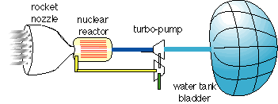
water propellant, nuclear heated steam rocket

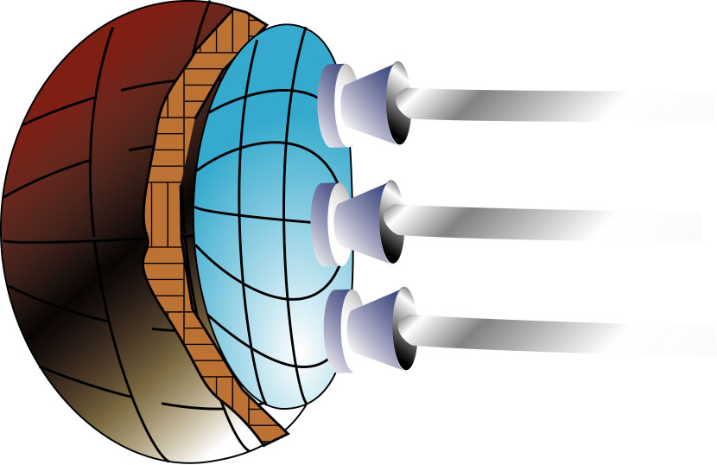
steam rockets propelling payload.
foil bag holding the water propellant.

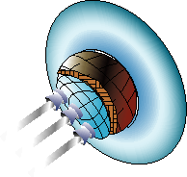
steam rockets propelling ice tire space ship,
using melted ice for propellant

We could even drink melted ice.

The main, key thing we had to pay attention to
was how to make the inner tube bags for the
Iceship.

-----------
Water Bags
We wanted to impress NASA.
So, we had to make sure the inner tube bags to hold water
would only weigh
as little as the payload of the Shuttle,
which was about 25 tons.

fortunately, my spreadsheet showed that an empty, 25 ton ice tire
would inflate withou enough water to make a smaller
iceship,
one that would hold 100 astronauts.

That's a hell of a lot of astronauts.

Or, for a bigger space ship,
the bags we could let the bags weigh as much as a whole space shuttle,
about 120 tons.
that would either make a space ship with a lot of room,
or
one to hold 500 astronauts.

Either way,
the deflated ice tire space ship
would be like a backpack tent,
only huge.

First, we would unpack our backpack,
space ship,
inner tubes,
bags made of parachute cloth,
or party balloon foils,
or something like that.

Then, we would
squirt water into it,
into the walls of the space ship.

The cold of space would freeze it.

Just that simple.
Of course.

Well, not quite.
I am a Physicist.
You would not expect
an Asperger-challenged physicist to
get the details part correct.

Even the NASA guys
got overview part of the picture.
At the NASA Johnson Space Center,
Houston,
I was trying to explain it to a crowd of
NASA experts.

I told how we would
just unpack our backpack,
a Shuttle payload.
We would
inflate it with water into a space ship.

To my total surprise,
they laughed.
They laughed with me.

This was the only time they ever laughed.

They all knew that ice was everywhere on planets and moons.
They all knew that meant we could Occupy the Solar System.
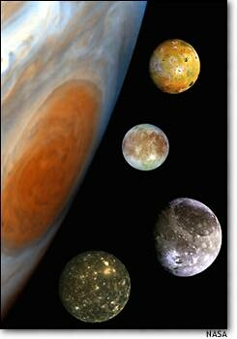
ice moons, Jupiter

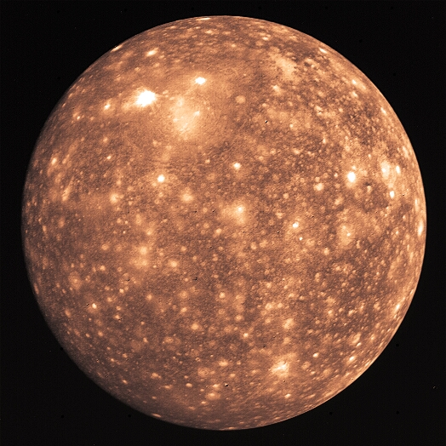
ice moon, Callisto, Jupiter

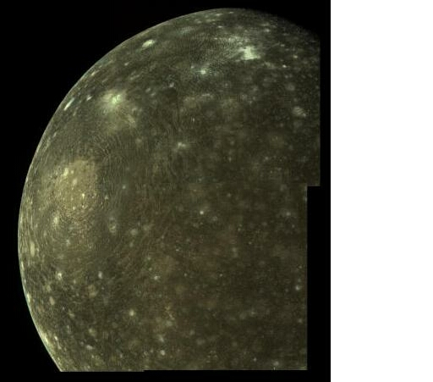
Callisto, Jupiter

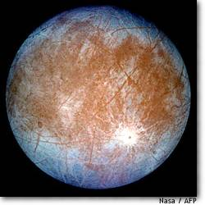
ice moon, Europa, Jupiter

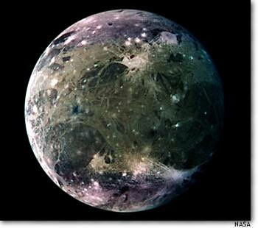
ice moon Ganymede, Jupiter

My iceship was
just like Dyson's starship.
I had figured the easy part.
Engineers figured the details.

-----------------
Joe Lewis Figured the Details
A detail would be how to pack insulation
into the space ship
so that it would not melt
from your body heat
when you lived in it.

Or,
so that the ice tire space ship would not freeze you
into a crystal ice mummy
first.

Another detail would be
to find a way to make the cold of space freeze the water
efficiently.
One would not want to carry a giant refrigerator into space.

A most important detail would be to make
the tank, the
water bag.

Joe Lewis, then at TRW in Los Angelis, figured these details out.
Joe Lewis was an expert on
"tanks," space tanks.
That meant he knew exactly how to make the water bag.
It was marvelous.

"poly benz oxazole" he said.
that would make the strongest, lightest bag ever.

He even described in detail
how to make the super thin layer
to coat the outside of the bag
so that the extreme cold of space would cool the water
without using a refrigerator.

Joe Lewis was the real inventor.
He figured the details.

I was just an Asperger type
doing my wild eyed physics.

END

(bottom, end of table) GO TO TOP

ppt 017 ice ship 20080108_2111.doc

plan 1/3/2008 8:35:52 AM
Complete Story Of Iceship,
- UCSB discovery
- brick ship Nancy
- NASA program presentation

ppt 025 ice ship
img aldrin's rotating cages held together by cables
img: ics ship graphic
img ice ship at INEL

puzzle piece: some "tanks" only need a bag
lesson: sometimes Nature is on your side: ppo membrane, low vapor pressure water, self freezing coating

suspense at the UCSD Library
inflate the ship
inflate with lava? Iceship nancy
Lava Ship
melt rock: lunar subterene LANL jim blacic made fluffy stuff.
his needed electricity
frozen rock could be difficult to work with.
frozen rock
fry rocks
fry the water out
puzzle piece: culture hotter than ours could use rocks
clue:
emotion: life is hard in space

Simplest
melt ice
get water
PBO bag
make space ships from melted stuff
rock and brick space ships
brick space ship of Nancy Linarez-Royces

TRW: PPO and self refrigeration
JSC laughed at inflate the ship

\ S2 CH 05.0 012 Powel-thru-iceship-Bx-.doc

